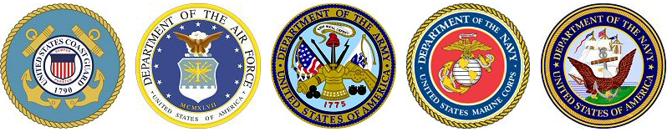

Military Visitation Schedule

~~ During Lunches in the center Cafeteria from 11:17 am – 1:32 pm ~~

**AIR FORCE**

**1st Tuesday of the month | TSgt Casey VanVeckhoven**

[**Glynn.Vanveckhoven@us.af.mil**](mailto:Glynn.Vanveckhoven@us.af.mil) **phone: 402-210-0640**

**ARMY**

**2nd Wednesday of the month | SSG Gene Thompson**

[**gene.d.thompson8.mil@army.mil**](mailto:gene.d.thompson8.mil@army.mil) **phone: 308-392-7093**

**MARINES**

**3rd Monday of the month | GySgt Wayne Stephan**

[**wayne.stephan@marines.usmc.mil**](mailto:wayne.stephan@marines.usmc.mil) **phone: 402-292-2477**

**Navy**

**3rd Thursday of the month | CS2 (SW) Daniel Grabenschroer**

[**daniel.s.grabenschro@navy.mil**](mailto:daniel.s.grabenschro@navy.mil) **phone: 402-575-0549**

**Nebraska Army National Guard**

**3rd Tuesday of the month | SPC Liz Contreras**

[**lizbeth.tzompantzi-contreras.mil@army.mil**](mailto:lizbeth.tzompantzi-contreras.mil@army.mil) **phone:** 402-618-0256

Military Service Academies

Lt. Col. Patrick Ryan, United States Air Force Academy | CDR Eric Taylor, United States Naval Academy

[patrick.ryan@ops.org](mailto:patrick.ryan@ops.org) phone: 402-990-1890 | **etaylor@1994.usna.com** phone:858-729-8348